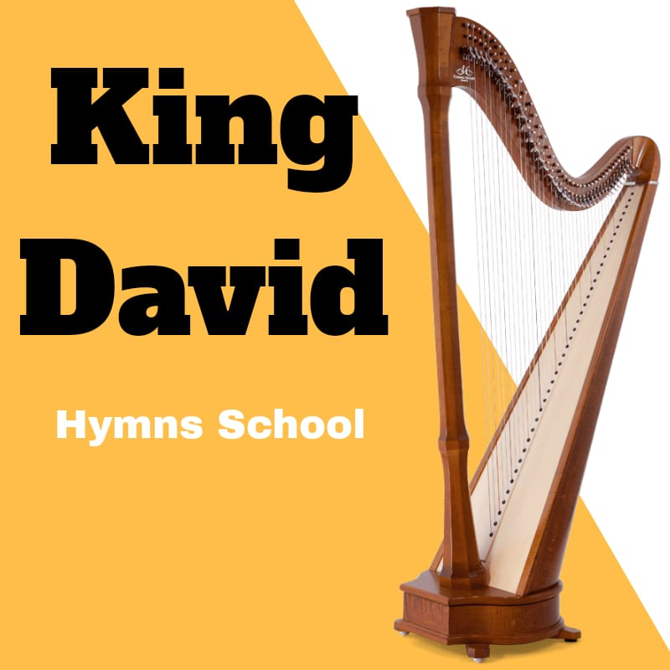
KING DAVID HYMN SCHOOL ENROLMENT FORM
NAME: _____________ LAST NAME: ______________
AGE: _____ SCHOOL YEAR: _________
ADDRESS: ____________________________ POST CODE: _______________
HOME NO: _________________ MOBILE NO: (04)_________
EMAIL ADDRESS: _________________________
Deaconship rank: _______________ Deaconess: _____________
Office use only
School name: ________________
Enrolment no: _______________________
Abouna’s signature
___________________
Principle’s signature
___________________

Add passport
Photo here
Parents signature
___________________

KING DAVID HYMN SCHOOL ID CARD ENROLMENT FORM
NAME: _____________ LAST NAME: ______________
AGE: _____ SCHOOL YEAR: _________
ADDRESS: ____________________________ POST CODE: _______________
HOME NO: _________________ MOBILE NO: (04)_________
EMAIL ADDRESS: _________________________
Deaconship rank: _______________ Deaconess: _____________
Office use only
School name: ________________
Id card no: _______________________
Abouna’s signature
___________________
Principle’s signature
___________________

Add passport
Photo here
Parents signature
___________________

KING DAVID HYMNS SCHOOL CIRCILLUM
Term 1: Hymns of the Holy Mass
. Pray for these/ Eprosevaxasti in both short and long tune | . We believe that this true
. Alleluia this is the day/ Alleluia vai pe pi | . We believe
. Alleluia the thought/ Alleluia jev mevee | . Again we believe
. One is the Holy/ Ispateer | . This is true
. Glory be/ Thoxa patri | . This is also true
. Stand up for prayer/ Epieprosevshee staste | . Amen we preach/ Amen ton thanaton
. Pray/ Eprosevasasti | . Kneel/ Ouoasht
. Lord have mercy/ kerylson | . We listen
. Pray that God/ Tobh hina | . Responses of the Litanies
. So | . Let the readers
. Tai shouree | . Pinishti
. Ti shouree | . Their holy/ Erpou
. Hitens | . As it was
. Hail o Mary/ Shere ne Maria | . We kneel to Your
. Holy God/ Agios otheos | . And Your honoured
. Pray for the Holy Gospel | . Through Christ/ Khen Pikherstos
. Stand in the fear | . Bow your head/ Tas
. Glory be to God/ Thoxasi kirie | . Before You/ Enopioan
. Truly blessed/ Onaiatou | . Saved amen/ Sotees
. And we look/ Tengousht in both tunes | . One is the Holy/ Iso panagios
. Pray for the perfect | . We listen with
. Greet | .Amen
. Through the intercession | . Psalm 150 in both Coptic and English
. They are with the Lord
. You seated stand up
. And look towards the east
. Let us listen
. The cherubim/ Ni sheroubeem
. Amen
. Amen we believe
. Let be according
. Truly
Term 2: Gerogorin Mass Responses
. The long greet one another
. Lord have mercy
. Kneel unto the Lamb
. Let it be according
. Have mercy/ Je nai nan
Term 3: Thoxologies of the Feasts
. Nayrooz Thoxology
. Feasts of the Cross Thoxology
. Koiak Thoxologies
. Paramon and the feast thoxologies of the Birth of Christ
. Thoxology of the feast of Circumcision
. Paramon and the feast thoxologies of the Epiphany
. Thoxology of the feast of the wedding of Cana of Galilee
. Thoxology of the feast of the Lord entering the Sanctuary
. Thoxology of the three days of the Fast of Nineveh
. Thoxologies of the Holy Great Fasting
. Thoxology of the feast of Annunciation
. Thoxology of Lazarus Saturday
. Thoxologies of Palm Sunday
. Thoxology of the Resurrection
. Thoxology for Archangel Michael for the Resurrection
. Thoxology of the Joyous Saturday
. Thoxology for Thomas Sunday
. Thoxology for the Feast of the Ascension
. Thoxology for the Feast of the Pentecost
. Thoxology for the Lord’s flight to Egypt
. Thoxology for the Feast of Transfiguration
Term 4: Hymns of the feasts
. Coptic New Year
. Feasts of the cross
. Month of koiak
. Paramon of the Feast of the birth of Christ
. Feast of the birth of Christ
. Feast of circumcision
. Paramon of the Feast of Epiphany
. Feast of the Epiphany
. Feast of the wedding of Cana of galilee
. Feast of the Lord entering the sanctuary
. Feast of the Annunciation
. Fast of Nineveh and Feast of Jonah
. Holy great fasting
. Lazarus Saturday
. Palm Sunday
. Passion weak
. Joyous Saturday
. Feast of the Resurrection
. Feast of the Lord’s flight to Egypt
. Feast of Ascension
. Feast of the Pentecost
. Fast and Feast of the Apostles
. Fast and Feast of St Mary
. Feast of Archangel Michael
. Feast of Transfiguration
Term 5: Hymns
. Wedding hymns
. Ebsali’s of the Feasts
. Praises before vespers
. Verses of the Cymbals yearly and the Feasts
. Conclusion verses for the yearly and the Feasts
. Introduction of thoxologies for Feasts and yearly
. Glorification Hymns
. Responses of the Feasts during the Holy Mass
. Hymns during Holy Communion
. Different Praises for St Mary and the Saints
Term 6: Rituals
. How to hold the wine properly
. How to Kneel properly
. How to do the censor properly
. Rituals of the Feasts
Term 7: Vespers
. Response of the departed
. Response of the sick
. Response of the travellers
. Response of the oblations
Term 8: Hymns of the Midnight Praises
. Tentheenou
. Tennav
. 1st Hoas
. 2nd Hoas
. 3rd Hoas
. Arpsalin
. Tenouh ensok
. Congregation of the Saints
. 4th Hoas
. 1st Sunday Ebsali
. 2nd Sunday Ebsali
. Conclusion of the Ebsalis
. Sunday Theotokia
. Conclusion of the Theotokias
Term 9: Coptic
. Coptic Alphabet
. Words for each Letter
. Coptic Consents
. Coptic Vowels
. Objects in Coptic
. Questions in Coptic for Male and Female
Term 10: Education
. Cymbals
. Triangle

